Smart MCQ Solver
A Comparative Study of From-Scratch, Classical, and Pretrained Models for Multiple-Choice Question Answering
BSDA2001P — Introduction to Deep Learning & GenAI · Project Report
Roll No: 22f3000768

1. Abstract / Executive Summary
This project addresses the Smart MCQ Solver Kaggle competition: given a question prompt and five candidate options (A–E), the task is to predict the correct answer and output the three most likely options, ranked. Performance is measured by Mean Average Precision at 3 (MAP@3). To study the trade-offs across the machine-learning spectrum, three model families were built and compared on an identical, leakage-free validation split: (1) a BiLSTM built from scratch, (2) a classical TF-IDF + Logistic Regression baseline, and (3) a fine-tuned DeBERTa-v3-small transformer. All three share a common design: each scores a single (prompt, option) pair to one number, and a softmax over the five scores produces the ranking.
The pretrained transformer performed best (validation MAP@3 = 0.7292), ahead of the classical baseline (0.6769) and the from-scratch BiLSTM (0.6645). Exploratory analysis revealed a 91.6% overlap between the test and training sets, which makes the public leaderboard largely a test of memorisation; the high-capacity BiLSTM, refit on all data, was therefore chosen for the final Kaggle submission. The key learning is that on a small dataset (2,000 rows) a pretrained model generalises best, while a from-scratch network overfits and barely edges out a classical linear model.

2. Introduction

Problem Statement
The competition provides multiple-choice questions, each with a prompt and five options A–E, exactly one of which is correct. The objective is to rank the options and submit the top three per question. The training set contains 2,000 rows (8 columns: id, prompt, A–E, answer) and the test set 500 rows (7 columns, answer withheld). The evaluation metric, MAP@3, awards 1.0 when the correct answer is ranked first, 0.5 when second, and 0.333 when third.

Project Objective
- Implement three distinct model types — a from-scratch neural network, a classical ML model, and a fine-tuned transformer — and compare them fairly.
- Establish an honest, leakage-free evaluation protocol given the dataset's duplicate questions.
- Gain practical mastery of PyTorch, Hugging Face Transformers, and experiment tracking with Weights & Biases.

Report Structure
Section 3 covers the dataset, EDA and preprocessing; Section 4 the tokenization strategy; Section 5 the three models; Section 6 the comparative performance analysis; and Section 7 the conclusions, challenges, and future work.

3. Dataset & Preprocessing

Dataset Description
Each record is a self-contained multiple-choice question. The training data (2,000 rows) includes the correct-answer label; the test data (500 rows) does not. No missing values were found after a null audit that also checked for disguised nulls (the strings "nan", "none", "null", and empty text).

Exploratory Data Analysis (EDA)
Answer-class imbalance. The correct option is not uniformly distributed: B is the answer 490 times, C 459, A 369, D 358, and E 324. A naïve always-B baseline would score ~24% accuracy — the floor to beat.
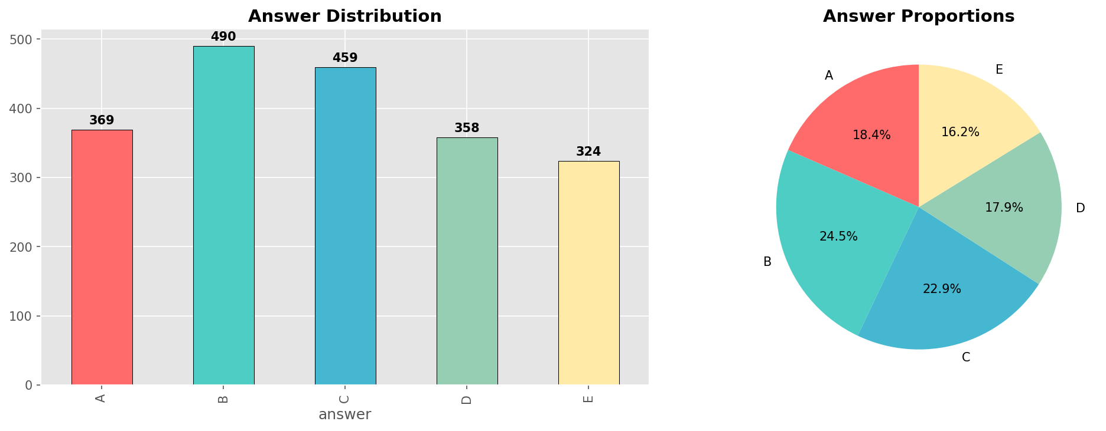
Fig 1. Distribution of the correct answer across the five options.
Length bias. Correct options are on average ~13.2% longer than incorrect ones — a shortcut a naïve model could exploit, and a confound worth being aware of.
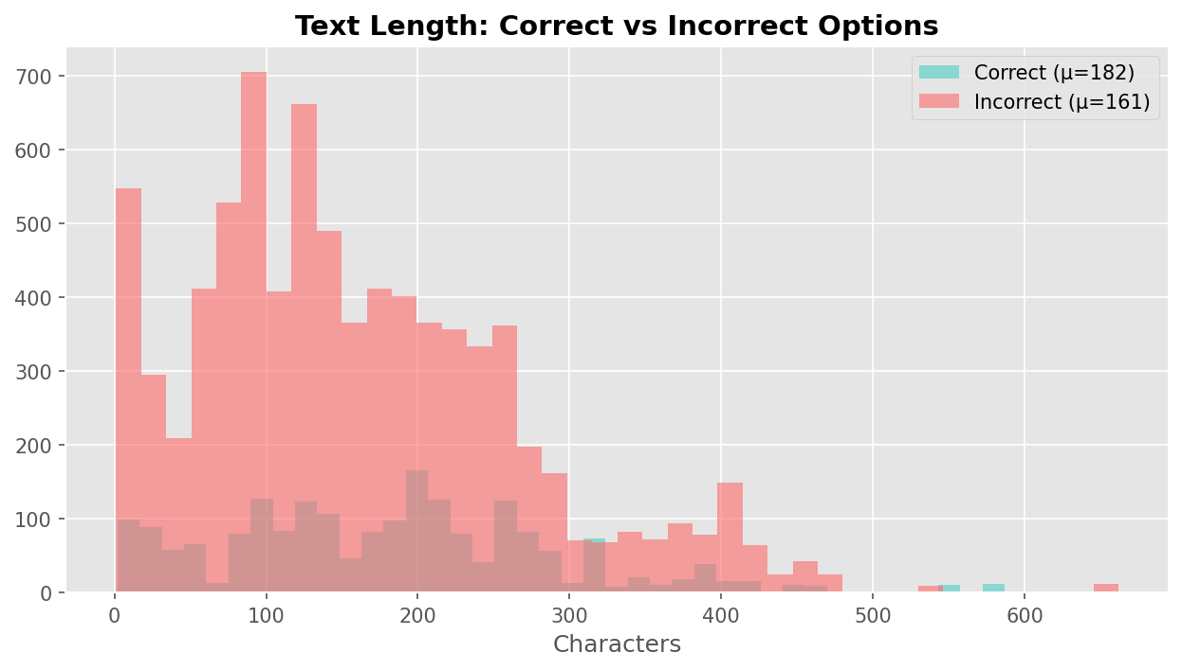Fig 2. Correct options are ~13.2% longer on average.
Train–test overlap. Fingerprinting each question by its concatenated options showed that 458 of 500 test questions (91.6%) also appear in training. This strongly shapes the modelling and evaluation strategy (Section 5) and explains the gap between validation and leaderboard behaviour.

Data Preprocessing
- Defensive cleaning: fill NaNs, cast to string, strip whitespace, collapse repeated whitespace to a single space, and replace any residual empty field with a "[no text]" placeholder so the model always receives a token.
- Text normalisation: lowercasing, punctuation removal, and whitespace collapsing.
- Instruction stripping: prompts begin with boilerplate such as "Pick the best possible answer:"; these prefixes carry no signal about the answer and are removed via regex so the model focuses on the core question.
- Consistency: identical cleaning is applied to train and test to avoid preprocessing skew.

Data Augmentation
No synthetic augmentation was used. Given the 91.6% train–test overlap, augmentation offered limited benefit, and the priority was an honest, leakage-free evaluation split (Section 5).

4. Tokenization Strategy

Primary Tokenizer (best model — DeBERTa-v3-small)
The best-performing model, DeBERTa-v3-small, uses a SentencePiece (Unigram) subword tokenizer, loaded via Hugging Face AutoTokenizer. Subword tokenization keeps the vocabulary compact while splitting rare or unseen words into known sub-units, avoiding out-of-vocabulary tokens. This matches DeBERTa's pretraining, so the fine-tuned model sees text segmented exactly as during pretraining — essential for transfer learning to work.

Implementation Details
- Pairing: each option is encoded jointly with the prompt as "prompt [SEP] option", with the special [CLS] token summarising the pair.
- Padding & truncation: sequences padded/truncated to a fixed max length (256 for DeBERTa, 200 for the BiLSTM) with an attention mask marking real vs padded positions.
- Batching: tokenization is batched through the Hugging Face pipeline for efficiency.

Experimental Comparison
Two other tokenization pipelines were used for the other models: a custom Byte-Pair Encoding (BPE) tokenizer (vocab 8,000, trained on the training split only) for the from-scratch BiLSTM — chosen because the domain vocabulary need not match any pretrained corpus and BPE yields a very low OOV rate; and word-level TF-IDF n-grams (unigrams + bigrams) for the classical model. SentencePiece was retained for the final model because it accompanies the pretrained DeBERTa weights.
5. Modeling & Experimentation

Shared design. All three models turn the 5-way choice into five independent (prompt, option) scoring problems: each pair is scored to a single number, and a softmax over the five numbers ranks the options. This section covers the three required model types.

5.1 Model 1: Fine-Tuned Transformer — DeBERTa-v3-small

Architecture
DeBERTa-v3-small (Microsoft) is an encoder-only transformer. Its novelty over BERT/RoBERTa is disentangled attention — representing a token's content and its relative position as two separate vectors — plus an enhanced mask decoder; DeBERTa-v3 further replaces masked-language-model pretraining with ELECTRA-style replaced-token detection. Hidden size is 768. (Reference: He et al., "DeBERTa: Decoding-enhanced BERT with Disentangled Attention", ICLR 2021; HF model card microsoft/deberta-v3-small.)

Salient Points
- Bidirectional self-attention gives each token full left-and-right context, ideal for understanding/classification.
- The final [CLS] hidden state (dimension 768) summarises each pair and is passed to a linear head producing one score.
- Pretraining on a large corpus means the model already "knows" English, so fine-tuning on 2,000 rows is enough to adapt it.

Fine-Tuning Strategy
- Optimizer: AdamW, learning rate 2e-5, weight decay 0.01 (excluded from bias and LayerNorm parameters).
- Schedule: linear schedule with 10% warmup; fp16 mixed precision; gradient accumulation over 2 steps (effective batch 16 on a batch-8 GPU).
- Epochs / layers: up to 5 epochs with early stopping on macro-F1 (patience 2); no layers frozen — freezing starves a small model on a small dataset.
Result: validation Accuracy 0.6037, Macro-F1 0.6097, MAP@3 0.7292 — the best of the three models.
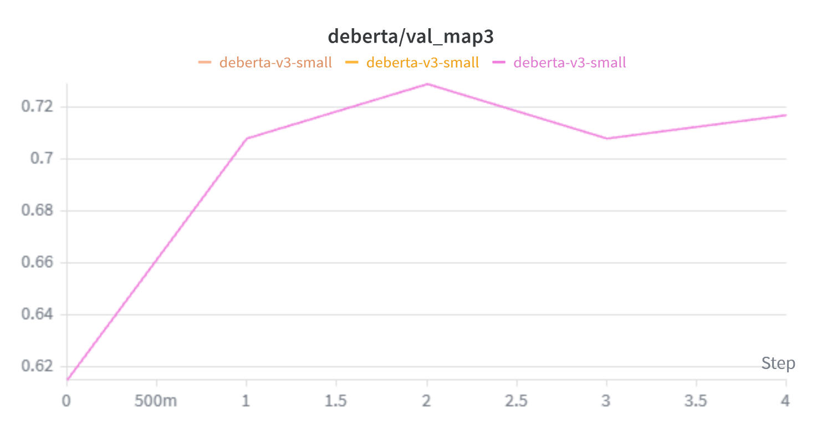

Fig 3. DeBERTa-v3-small training/validation curves (W&B).

5.2 Model 2: Custom Deep Learning Model — BiLSTM (from scratch)
Note: this from-scratch bidirectional LSTM satisfies both the custom-deep-learning and the RNN-based requirement — it is a custom recurrent network built without any pretrained weights.

Architecture
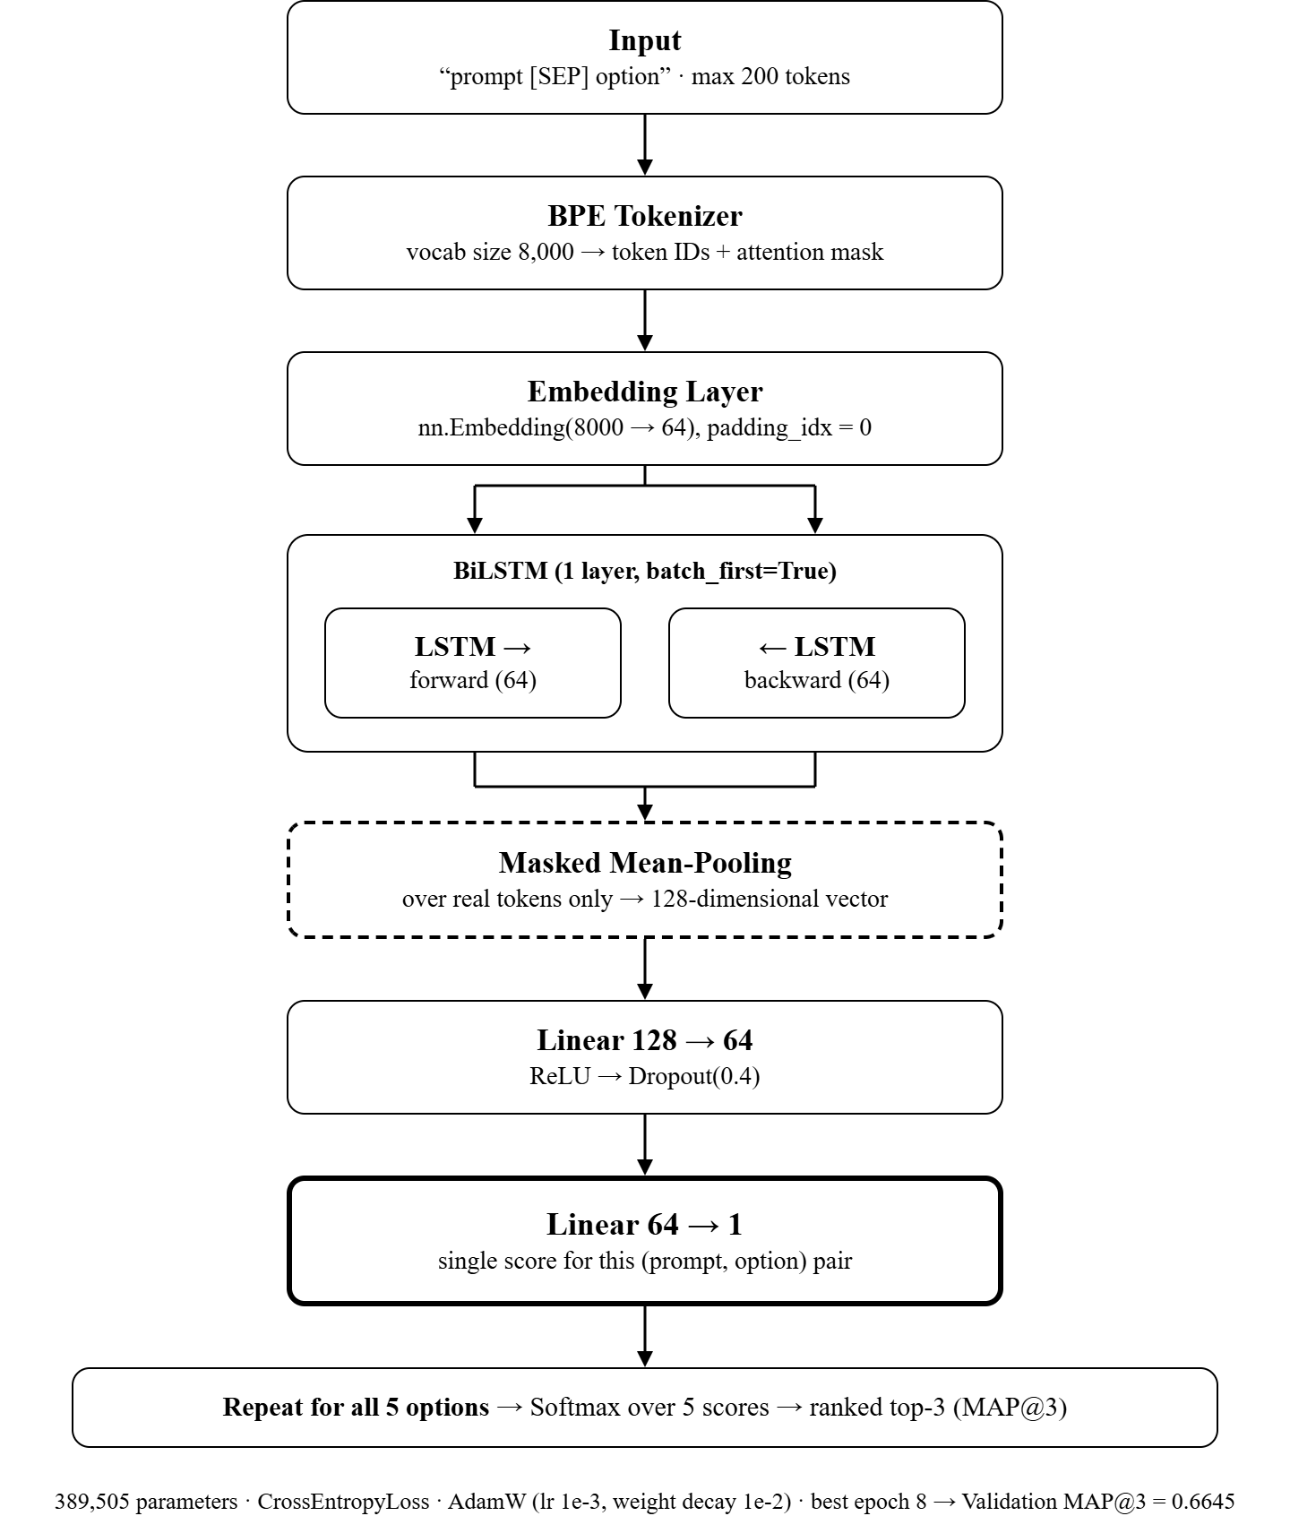

Fig 4. BiLSTM pair-scorer architecture (built from scratch, 389,505 parameters).
Pipeline: BPE token IDs → learnable nn.Embedding (8000→64, padding_idx=0) → a single bidirectional LSTM (64 hidden units per direction, batch_first=True) → masked mean-pooling over real tokens into a 128-d vector → Linear(128→64) → ReLU → Dropout(0.4) → Linear(64→1). The five per-option scores are stacked and softmaxed to rank.

Salient Points
- Bidirectionality gives each token both preceding and following context — important for judging how well an option completes a prompt.
- Masked mean-pooling averages only over real tokens, so padding does not dilute the sentence representation.
- The model is deliberately small (389,505 parameters) with strong regularisation (dropout 0.4, weight decay 1e-2) because 2,000 rows overfit easily.

Training
- Loss: CrossEntropyLoss over the five scores. Optimizer: AdamW (lr 1e-3, weight decay 1e-2, raised 100× to fight overfitting).
- ReduceLROnPlateau scheduler, AMP mixed precision, gradient clipping (norm 1.0), early stopping (patience 4).
- Overfitting evidence: training accuracy climbed to 0.97 by epoch 12 while validation MAP@3 peaked at epoch 8 (0.6645) — the classic train-up/val-flat signature. The best (epoch-8) checkpoint was kept.
Result: validation Accuracy 0.5266, Macro-F1 0.5158, MAP@3 0.6645 (honest, leakage-free).
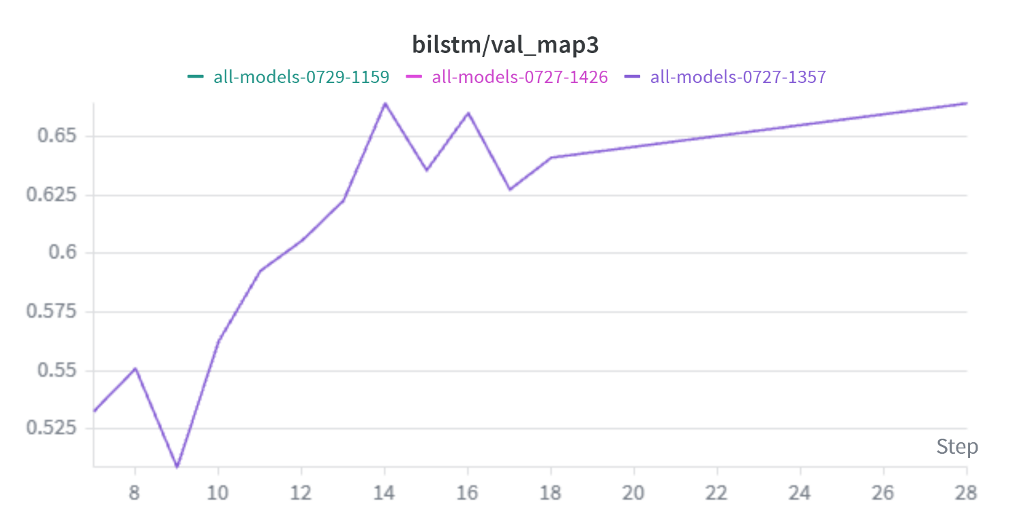
Fig 5. BiLSTM loss and validation MAP@3 (W&B).

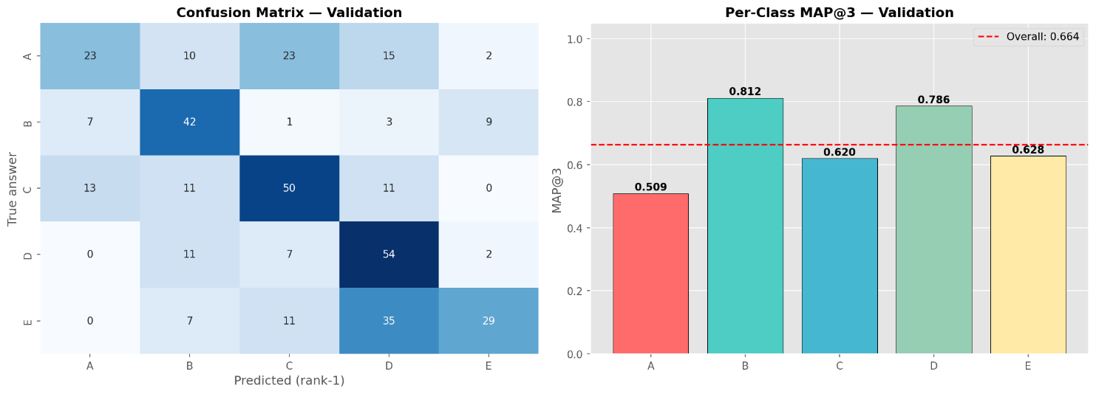
Fig 6. BiLSTM confusion matrix — best class B (MAP@3 0.812), weakest A (0.509).

5.3 Model 3: Classical ML Baseline — TF-IDF + Logistic Regression

Architecture
Each option is paired with the prompt as "prompt [SEP] option" and labelled 1 if it is the answer, turning the task into a binary "is this pair correct?" problem. A scikit-learn Pipeline chains a Tf-IDF Vectorizer (unigrams + bigrams, max_features 20,000, sublinear_tf, English stop-words) with a Logistic Regression (C=10, class_weight='balanced'). At inference, predict_proba[:,1] gives P(correct) per pair; the five probabilities per question form the ranking scores.

Salient Points
- TF-IDF weights each term by how frequent it is here and how rare across the corpus, highlighting distinctive words; bigrams capture short phrases such as negations.
- class_weight = 'balanced' corrects the 80/20 pair imbalance (only 1 of 5 pairs is positive).
- A linear model cannot memorise arbitrary mappings, so it generalises well relative to its cost — a strong, cheap baseline.
Result: validation Accuracy 0.5293, Macro-F1 0.5243, MAP@3 0.6769 — narrowly ahead of the from-scratch BiLSTM, underlining that deep learning needs more data to pay off.
6. Performance & Comparative Analysis

Evaluation Metrics
Primary metric: MAP@3 (the competition metric). Also reported: rank-1 accuracy and macro-F1 (per-class F1 averaged equally, so a weak option class cannot hide behind the average). All models are evaluated on the same 376-question validation set.

Validation Protocol (leakage-free)
Because the dataset contains duplicate questions, a random split would leak a question's twin into validation and measure memorisation. A StratifiedGroupKFold split was used: questions with identical options share a fingerprint and are forced entirely into either train (1,624) or validation (376), never split across both, while answer-class proportions are balanced. An assertion confirms zero group overlap between the two sets.

Comparative Report
Model | Type | Accuracy | Macro-F1 | MAP@3
BiLSTM | From scratch | 0.5266 | 0.5158 | 0.6645
TF-IDF + Logistic Regression | Classical ML | 0.5293 | 0.5243 | 0.6769
DeBERTa-v3-small | Pretrained | 0.6037 | 0.6097 | 0.7292

Discussion. The pretrained DeBERTa leads on every metric (MAP@3 +5.2 points over the classical baseline), justifying its higher compute cost for accuracy-critical use. Strikingly, the from-scratch BiLSTM (~390k parameters, trained for minutes) is beaten by a linear model: with only 2,000 rows it cannot learn language representations from scratch and overfits, whereas TF-IDF + LogReg makes fewer assumptions and generalises slightly better. The trade-off is clear — the transformer buys accuracy with compute and training time; the classical model is near-instant and a strong baseline.
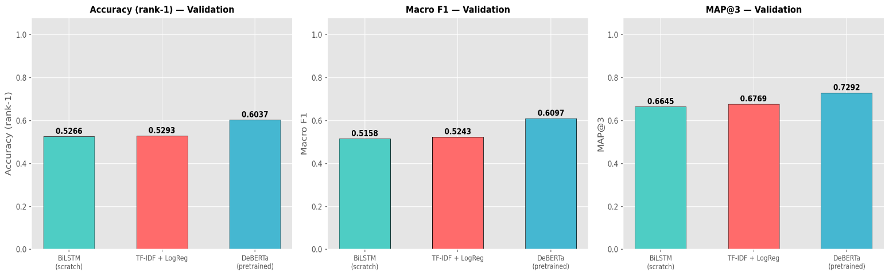
]
Fig 7. Model comparison across accuracy, macro-F1, and MAP@3 (W&B).

Kaggle Performance
The final submission uses the BiLSTM predictions. Although DeBERTa wins on the leakage-free validation set, the public leaderboard is dominated by the 91.6% train–test overlap and therefore rewards memorisation; the high-capacity BiLSTM, refit on all 2,000 rows, recalls seen questions best and scored highest publicly. Final Kaggle score: 0.74231 Rank: 858.

7. Conclusion & Future Work

Key Learnings
- On small datasets, a pretrained transformer generalises best; a from-scratch network overfits and may not beat a simple linear model.
- Honest evaluation matters as much as modelling: duplicate questions demanded a group-aware split, and validation vs leaderboard measure different things (generalisation vs memorisation).
- Practical fluency gained in PyTorch, Hugging Face fine-tuning (warmup, gradient accumulation, mixed precision), and W&B experiment tracking.

Challenges Faced
- Data leakage from duplicates — solved with StratifiedGroupKFold and an overlap assertion.
- BiLSTM overfitting — mitigated with dropout 0.4, 100× stronger weight decay, gradient clipping, and early stopping.
- GPU memory for DeBERTa — handled with fp16 and gradient accumulation.

Areas for Improvement
- Ensemble the three models (e.g. average probabilities) for a likely MAP@3 gain.
- Refit DeBERTa on 100% of the data (as done for the BiLSTM) so it also benefits on the overlap-heavy leaderboard.
- Try a larger DeBERTa variant, hyperparameter search, and prompt/option-order data augmentation.

8. References
[1] He, P., Liu, X., Gao, J., & Chen, W. (2021). DeBERTa: Decoding-enhanced BERT with Disentangled Attention. ICLR.
[2] Hochreiter, S., & Schmidhuber, J. (1997). Long Short-Term Memory. Neural Computation, 9(8).
[3] Vaswani, A., et al. (2017). Attention Is All You Need. NeurIPS.
[4] Hugging Face model card: microsoft/deberta-v3-small — https://huggingface.co/microsoft/deberta-v3-small
[5] Wolf, T., et al. (2020). Transformers: State-of-the-Art Natural Language Processing. EMNLP (System Demonstrations).
[6] Pedregosa, F., et al. (2011). Scikit-learn: Machine Learning in Python. JMLR, 12.
[7] Paszke, A., et al. (2019). PyTorch: An Imperative Style, High-Performance Deep Learning Library. NeurIPS.
W&B project: wandb.ai/22f3000768-dl-genai-project/smart-mcq-solver

